

NATIONAL POLICE CHIEFS’ COUNCIL - JOB DESCRIPTION

1. Job Details
Job Title: | Communications Manager – Engagement and Coordination
Reports to: | Head of Media and Public Affairs
Grade | Band C
Vetting Level | NPPV2 & CTC
Location | 10 Victoria Street, London, with flexibility to work remotely.

2. Organisation Chart
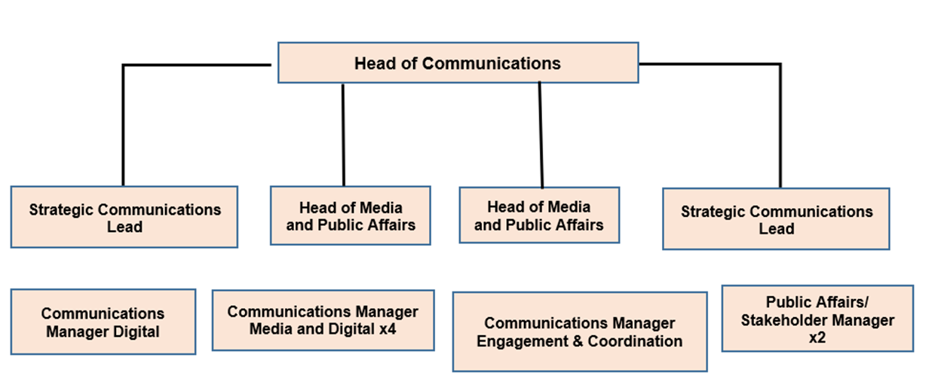

3. Job Purpose
To coordinate communications activity across the NPCC communications team and with wider NPCC teams to support the delivery of our communications strategy and business plan.
To lead communication with NPCC members and key partners that supports strong relationships and collaborative working with a particular focus on communicating change.

4. Knowledge, Skills and Experience
Knowledge:
- Expert knowledge of what great communication looks like and can achieve and how it links with policy and other communication disciplines.
- Up to date professional knowledge of best practice in relation to corporate communications or internal or stakeholder communications and knowledge of a broad range of current communication practices, tools and techniques including OASIS communication planning frameworks and insight and evaluation.
Skills:
- Ability to provide communications advice and guidance at a senior level and use skills and experience to influence strategies and plans, including representing communications issues at high level meetings.
- A problem solver with a positive outlook who isn’t phased by complex business problems requiring creative communication solutions.
- Excellent written communication skills across a variety of channels and audiences, working at pace.
- Ability to plan, create and commission high quality content.
- Ability to work flexibly in managing a range of activities and operate in a fast-paced and pressurised environment, prioritising and making decisions under pressure.
- Ability to evaluate, analyse and swiftly summarise information gathered from a range of sources to identify important issues, be able to make unbiased and accurate decisions on complex issues and communicate complex or contentious issues clearly and sensitively.
- Highly developed organisational, planning and project management skills.
- Accomplished user of Microsoft Word, PowerPoint and Excel and skill in designing and presenting content with the ability to quickly pick up new tools and techniques.
Experience:
- Experience of developing and delivering high quality communication strategies and handling plans for internal or stakeholder audiences aligned to corporate objectives or challenges built on insight, employing creative content, and evaluated for continuous improvement.
- Strong track record of building strong relationships with internal and external stakeholders to achieve mutually successful business and communications outcomes.
- Experience of reactive media handling.

5. Key responsibilities and focus of the role
Coordination
- Work with colleagues across the NPCC to coordinate activity and across Communications to integrate media plans, social media plans and stakeholder engagement into a coordinated plan.
- Maintain a master grid of all communication projects and a planning grid covering range of proactive and reactive, owned and stakeholder-led activity. Work with internal and external stakeholders to ensure the planning grid is reflective of relevant activity and plans from both NPCC and partners.
- Ensure effective communication of key NPCC communication projects and plans to relevant partners, determining and developing appropriate channels and content.

Engagement
- Develop, deliver, monitor, and evaluate strategies and handling plans for communicating with the NPCC membership (NPCC staff, chief officers across the country, NPCC leads and their staff, force communication teams) and key policing partners.
- Providing strategic communication advice to senior leaders and programme teams to develop and deliver effective strategies, plans and materials.
- Develop strategic relationships with key partners that enable us to co-create and collaborate on content, amplify our messages, and increase the reach and impact of our communications.
- Establishing common engagement principles and best practice to improve the quality of membership engagement.
- Create or commission engaging impactive products and content to aid engagement including sourcing, developing, and commissioning images, infographics, and other products as required.
- Act as a champion for brand, digital and editorial standards, and communication processes. Assure the quality of our products and services in line with standards and guidelines, ensuring timely action is taken if they fail to meet standards.
General
- Manage a portfolio of NPCC projects, problem solving and monitoring own and colleagues’ work against plans and milestones and act promptly to ensure activity stays on track and outcomes are delivered.
- Seek external insight, research, best practice, and new ideas to contribute to the development of the department.
- Contribute to communications planning and response to crises or major incidents and events.
- Manage other communications tasks and projects as required.
- Actively seek learning and development opportunities to enhance role.
- Be prepared to work out of normal office hours if circumstances demand it and at short notice.
Media
- Contribute to a Rota for reactive media handling (one day in six), triaging reactive enquiries against the business plan, weighing up priorities, risks, and opportunities to make decisions and recommendations about the most appropriate response. Preparing concise statements and rapid rebuttals.
- Be part of a 24/7 on call rota outside of office hours (weekends one day in seven, weekdays one day in six) to respond to:
- urgent out of hours enquiries from media, forces and stakeholders.
- requests for support from NPCC leads and chairs.
- maintain awareness of significant or breaking policing issues and respond as necessary.
- provide out-of-hours support for interviews i.e., monitoring, preparing briefs and accompanying chiefs.

