

NATIONAL POLICE CHIEFS’ COUNCIL - JOB DESCRIPTION
1. Job Details
Job Title: | NPCC Criminal Justice Coordination Committee CJ National Improvement Lead
Reports to: | NPCC Criminal Justice Coordination Committee Chair
Rank | Assistant Chief Constable /BB3 (staff)
Vetting Level | NPPV3 & SC
Location | Remote working nationally within UK. NPCC is currently based at 10 Victoria Street, London and therefore occasional travel will be required to this premise and other Police locations across the UK. We encourage applications from candidates living across the UK. Further details on flexible arrangements will be discussed at interview stage  .

2. Organisation Chart
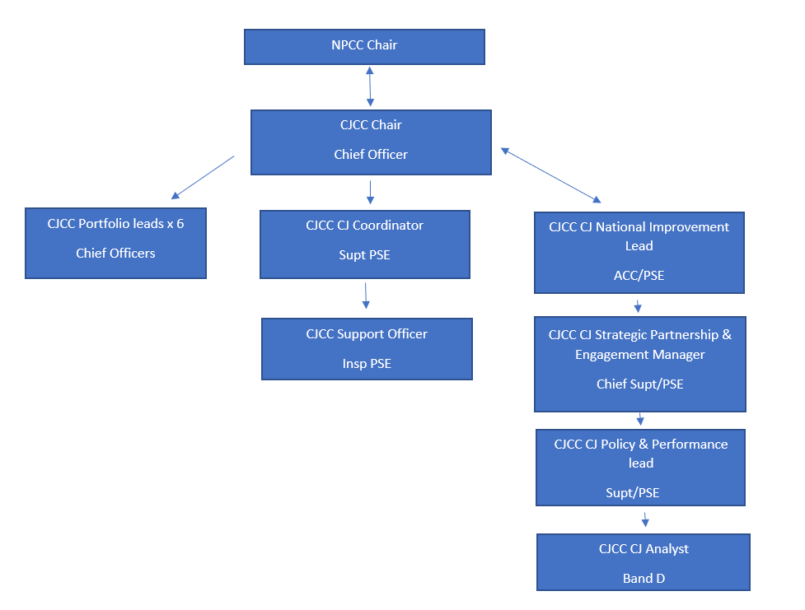

3. Job Purpose
This NPCC role, supported by three other roles, has been created with the support of the Home Office, to provide enhanced national coordination, complementing the current NPCC arrangements, to support forces to improve criminal justice outcomes, navigate the increasingly complex criminal justice landscape and ensure that the victim is placed at the heart to improve trust and confidence in the system.

The role holder will:
- Support the Chair of the CJ Committee, including deputising where necessary
- Represent the CJCC at strategic level
- Provide strategic direction to the CJCC
- Lead, develop and implement a Criminal Justice Improvement Plan, in collaboration with the NPCC CJ Chair and partners across policing and the Criminal Justice System, in alignment with wider plans and objectives.
- Drive the programme of activity, coordinating strategic level direction and planning, delivering against the plans and engaging with key stakeholders
- Monitor and ensure delivering of key objectives of the CJ Improvement Plan and report on progress through the CJCC
- Effectively analyse, evaluate and report on performance within the CJS, utilising findings to drive improvements in service delivery
- Report on progress to critical forums, such as Chiefs Council
- Work in partnership with stakeholders across the criminal justice system to ensure effective join-up across plans and activity that improve the systems response to the challenges facing CJ
- Support forces by providing expert insight and advice, share best practice and thereby drive improvement across the system, aiming for an overall leveling up of performance and bring consistency
- Deliver expert input and insight to forces through a series of roadshows and through an annual conference, sharing best practice and updating forces on relevant legislation/policy changes
- Contribute to the vision and strategy of the NPCC CJ Committee, working alongside the CJ Committee Chair
- Work across NPCC Committees/Portfolios to ensure a consistent and joined up approach to criminal justice, identifying and sharing best practice

4. Knowledge, Skills and Experience
Essential Criteria
- Strong strategic awareness of the relevant challenges, considerations and issues facing the Criminal Justice System
- Credible track record in delivery at national level
- Extensive background in strategic partnerships and cross agency working
- Strong sense of political awareness
- Substantial, professional experience and knowledge in successfully leading through change, developing and implementing innovative solutions to issues and problems
- Demonstrate the ability to grasp and understand complexity and uncertainty and make sound evidence-based decisions.
- Strong ability to effectively challenge and influence stakeholders, quickly acquiring and retaining credibility, building effective working relationships with internal and external stakeholders and working collaboratively to achieve objectives
- Proven experience in setting a strategic framework for action and required delivery, including setting and managing budgets and timeframes, holding individuals, teams and stakeholders to account against delivery measures
- Significant experience in the development of complex plans and the management of multi-disciplinary teams to deliver against them.
- Proven experience in working collaboratively with internal and external partners across projects which delivered a conflicting range of customer requirements within tight budget, resource and time constraints
- Able to systematically analyse and cut through complexity to bring clear, relevant and intelligible recommendations
- Able to apply judgement creatively and flexibly to solve complex problems and generate new ideas.
- Effective people manager with the ability to draw together required resources, encourage diversity and motivate others to deliver required outcomes.

5. Communications and Working Relationships
Exceptional communication skills are vital to this complex role. The role holder will be accountable to the NPCC CJ Committee Chair and will also report into the NPCC.

The role holder will have regular communications with Chief Officers in England and Wales, NPCC, NPCC leads, their staff, government departments and key stakeholders, and be required to develop and maintain those relationships. This role requires the job holder to engage with a variety of national bodies and individuals at a strategic level. These people and organisations include, but are not restricted to:
- Home Office Ministers and their offices
- Ministry of Justice
- Crown Prosecution Service (CPS)
- Members of the Judiciary
- His Majesty’s Courts and Tribunal Service (HMCTS)
- College of Policing
- Association of Police and Crime Commissioners (APCC)
- Other relevant partner organisations and stakeholders

6. Dimensions
The role holder has direct supervisory responsibility of the NPCC CJ Strategic Partnerships and Engagement Manager and will have overall responsibility for a programme team of 3 officers/police staff.

The role holder has limited budgetary responsibilities.

They must have the knowledge, confidence and skill to lead, influence and advise Officers and staff at all levels.

The role holder is required to have knowledge of national issues across a broad range of subject matter to enable them to support the development and implementation of the programme involving stakeholders from across the Police Service and organisations.

This role requires regular travel to London and across the UK.

For further information please contact hr-recruitment@npcc.police.uk

