

NATIONAL POLICE CHIEFS’ COUNCIL - JOB DESCRIPTION

1. Job Details
Job Title: | NPCC CJ Committee Criminal Justice Strategic Lead
Reports to: | CJCC CJ National Improvement Lead
Rank: | Chief Superintendent (or Supt on promotion)
Vetting Level | NPPV 3 and SC
Location | Remote working nationally within UK. NPCC is currently based at 10 Victoria Street, London and therefore occasional travel will be required to this premise and other Police locations across the UK. The job holder will be required to travel across the UK to deliver roadshows/peer reviews.  We encourage applications from candidates living across the UK. Further details on flexible arrangements will be discussed at interview stage.

2. Organisation Chart
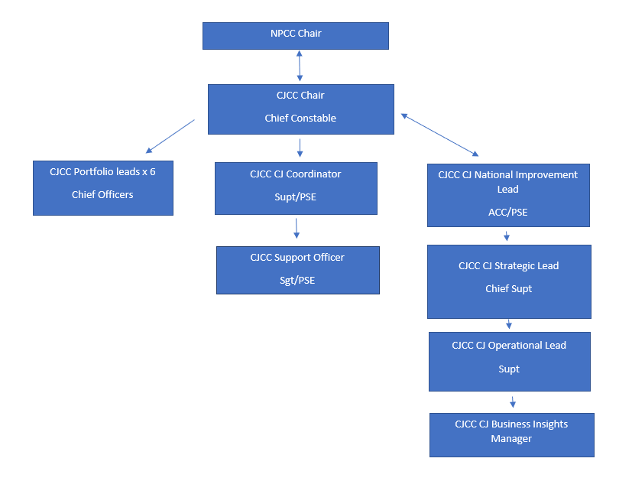

3. Job Purpose
The Chief Superintendent will provide support to the CJCC CJ National Improvement Lead and to the wider NPCC Criminal Justice Committee to deliver priorities set by the CJCC and identified through the CJ Improvement Plan to improve Criminal Justice outcomes and support forces in navigating the increasingly complex criminal justice landscape.

4. Knowledge, Skills and Experience
Knowledge:
- Broad understanding of the criminal justice system and the challenges facing policing and the wider Criminal Justice System.
- The job holder is required to have knowledge of national issues across a broad range of subject matter to enable them to support the development and implementation of the programme involving stakeholders from across the Police Service and organisations.

Skills:
- This role requires liaison between the NPCC, Police forces, HO, CPS, HMCTS, APCC, HMICFRS, College of Policing, and other key stakeholders.
- The ability to work effectively with the NPCC Strategic Hub and committee coordinators to ensure deliverables are in line with NPCC and wider policing priorities.
- Ability and confidence to present and lead discussions on complex and/or contentious concepts and, where appropriate, use simple, succinct terms to lay audiences orally and in writing.
- Demonstrate the ability to grasp and understand complexity and uncertainty and make sound evidence based decisions.
- Able to systematically analyse and cut through complexity to bring clear, relevant and intelligible recommendations
- Able to apply judgement creatively and flexibly to solve complex problems and generate new ideas.
- Ability to effectively challenge and influence senior managers, quickly acquiring and retaining credibility, building effective working relationships with internal and external stakeholders and working collaboratively to achieve objectives.

Experience:
- Experience of designing, writing, and presenting structured reports, briefings, and presentations on behalf of senior management at strategic national level boards, forums and conferences
- Experience of coordinating actions and updates for relevant meetings, within deadlines.
- Background in strategic partnerships and cross agency working
- Experience and knowledge in successfully leading through change, developing and implementing innovative solutions to issues and problems.
- Experience in setting a strategic framework for action and required delivery, including setting and managing budgets and timeframes, holding individuals, teams and stakeholders to account against delivery measures
- Experience in the development of complex plans and the management of multi-disciplinary teams to deliver against them.
- Proven experience in working collaboratively with internal and external partners across projects which delivered a conflicting range of customer requirements within tight budget, resource and time constraints

5. Key responsibilities and focus of the role
The role holder will:
- Provide support to both the CJCC CJ National Improvement lead and the NPCC CJCC Chair
- Provide the provision of efficient and effective organisational and development change across the NPCC CJ Committee in line with agreed priorities. As directed by the CJCC Chair and National Improvement Lead ensure programme objectives and benefits are realised.
- Show initiative and logical thought processes in solving problems that may arise due to cross agency working.
- Identify and engage stakeholders and those impacted by the change throughout the CJ improvement programme. Represent the CJCC at all relevant Force meetings.
- Work with all relevant senior colleagues to ensure that dependencies are managed to ensure change is embedded, practical benefits are delivered and lessons learned are recorded, in order to develop the organisational memory and support organisational learning.
- Manage relevant aspects of CJ programme resourcing and budget management to ensure that programmes are kept on track and delivery is within the time, cost and quality tolerances.
- Act as an effective conduit between forces, CJ stakeholders and delivery partners
- Work with forces and the CoP as a subject matter expert
- Keep partnerships engaged and functioning
- Provide leadership, influence, vision, support and advice across portfolios, adding value by acting as a critical advisor on key business area decisions
- Provide advice and guidance to forces through peer reviews, roadshows, drop in sessions
- Consider proposals put forward by stakeholders in relation to national criminal justice matters and assist in decision making on whether to take these forward
- Analyse and update reports on progress against delivery, ensure that risks and issues are monitored on a regular basis and actively updated and mitigated against. Escalate risks and issues when appropriate
- Attend appropriate governance meetings/boards and to deputise for CJCC Chair or National Improvement Lead where appropriate
- Talk positively about the criminal justice system and what it can achieve building pride and self esteem
- Work closely with NPCC Committees/Portfolio leads to ensure deliverables are in line with NPCC and wider priorities
- Ensure that the victim is at the heart of decision making

