

NATIONAL POLICE CHIEFS’ COUNCIL - JOB DESCRIPTION

1. Job Details
Job Title: | Performance Management Committee Coordinator
Reports to: | Performance Management Coordination Committee Chair
Grade | A / Superintendent
Vetting Level | NPPV3/MV & SC
Location | Remote working nationally within UK. NPCC is currently based at 10 Victoria Street, London and therefore occasional travel will be required to this premise and other Police locations across the UK. We encourage applications from candidates living across the UK. Further details on flexible arrangements will be discussed at interview stage.

2. Organisation Chart
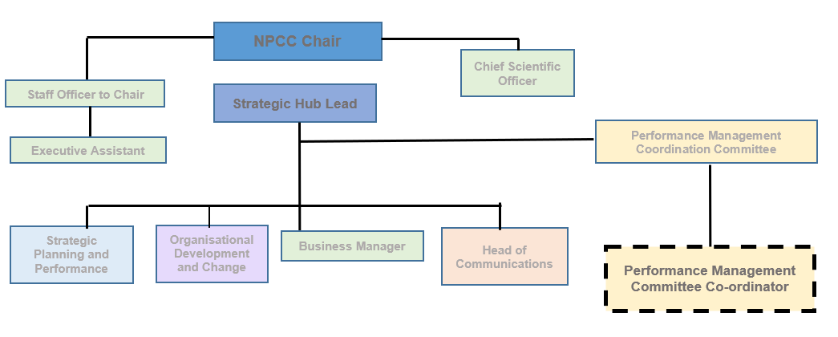

3. Job Purpose
The post holder will provide support to the National Police Chiefs’ Council Performance Management Coordination Committee (PMCC) Chair in delivering national coordination of portfolios across the full range of their responsibilities, including Chair of PMCC; NPCC representation at Police Performance Oversight Group, Force Management Statement steering group, Crime and Police Performance Board, National Crime Recording Standards Steering Group, HMICFRS PEEL External Reference Group.

The post holder will coordinate the national PMCC governance landscape across the range of Business, Technical, Security and Information practitioners. Operating as an integral part of the NPCC Strategic Hub and furthering productive working relationships between Committees, key stakeholders, and partners. Representing the Committee Chair and NPCC at key meetings when required.

The role is also an integral part of the National Police Chiefs’ Council Strategic Hub and contributes towards the delivery of the NPCC objectives and annual plan.

4. Knowledge, Skills and Experience
Knowledge:
- Knowledge of the strategic and operating environment of UK policing would be a distinct advantage.
- To have detailed experience and knowledge of implementing business change at a strategic level.
- The job holder is required to have knowledge of national issues across a broad range of subject matter to enable them to support the development and implementation of the programme involving stakeholders from across the Police Service and organisations.

Skills:
- Decision-making is required and the post holder will need to call constantly on their problem-solving skills. The job holder will frequently have to work on their own initiative and escalate issues within the NPCC and Performance Management Committee governance structure as required.
- The job holder will have regular communications with Chief Constables, NPCC Hub team, NPCC leads, their staff, government departments and key stakeholders, and be required to develop and maintain those relationships.
- This role requires liaison between the NPCC, Police forces, Minister for Policing as chair Crime Police Performance Board, APCC, HMICFRS, College of Policing, NCA and other key stakeholders.
- The ability to build and maintain effective and open relationship with HMICFRS, Home Office, APCC, NCA and College of Policing.
- The ability to work effectively with the NPCC Strategic Hub and committee coordinators to ensure deliverables are in line with NPCC and wider policing priorities.
- Demonstrate the ability to produce relevant papers, documents, and reports to inform and support key decision-making structures, benefit management and the implementation of priorities.

Experience:
- Experience of overseeing and managing the progress of priority national risk areas, providing detailed updates on any strategic policy issues and actions required, and supporting national policing legal representation through Judicial Review proceedings against national policy as a subject matter expert.
- Experience of designing, writing, and presenting structured reports, briefings, and presentations on behalf of senior management at strategic national level Boards, Forums and Conferences.
- Experience of coordinating actions & updates for relevant meetings. Providing briefings for meetings as appropriate, within the deadlines required.
- Demonstrate the ability to analyse and update reports on progress against delivery.

5. Key responsibilities and focus of the role
- Coordinating the national PMCC governance landscape across the range of Business, Technical, Security and Information practitioners. Furthering productive working relationships between Coordinating Portfolios across the themes of HMICFRS, Planning and Professionalising, Home Office Liaison for Crime Recording and Standards (NCRSSG), Research and Development, Information and Insight, and Association of Police and Crime Commissioners.
- Coordination of the PMCC response to calls for evidence and the production of data and insight into the National Policing Board (NPB) and its sub-boards and other relevant government/Ministerial level meetings.
- Liaison with members of the Digital Crime and Performance Pack (DCPP) collaboration, and close monitoring of the delivery of DCPP products in conjunction with the Strategy, Planning and Performance (SPP) team.
- Working closely with the NPCC Strategic Hub and committee coordinators to ensure deliverables are in line with NPCC and wider policing priorities.
- Attending a wide range of critical strategic meetings in support of the Chair. These will include meetings of NPCC, Association of Police & Crime Commissioners (APCC), Home Office, and Chief Constables Council.
- Keeping partnerships engaged and functioning including government, public and private sectors, legislators, Inspectorates and Regulators.
- To attend appropriate governance meetings / boards and to deputise or represent the NPCC PMCC Chair where appropriate.
- In conjunction with the SPP team provide liaison between the NPCC, Police forces, Minister for Policing as chair Crime Police Performance Board, APCC, HMICFRS, College of Policing, NCA and other key stakeholders.
- Working closely with the SPP team on joint products and insight for the benefit of the NPCC as a whole.
- To provide leadership, influence, vision, support, and advice across our portfolios, adding value by acting as critical advisor on key business area decisions.
- To develop strong and professional working relationships and credibility with senior leaders with the NPCC coordination committee structure including other committee coordinators and colleagues within the Strategic Hub Home Office, APCC, College of Policing, NCA and HMICFRS.
- Develop and maintain PMCC national business plan supporting NPCC vision and strategic plan.
- To provide advice and guidance to police forces and senior Policing Leaders.
- Consider proposals put forward by stakeholders in relation to national performance matters and assist in decision making on whether to take these proposals forward.
- Review all Chief Constables’ Council Papers to ensure implications have been clearly communicated to the Chair and Strategic Hub and the full cost, benefit and risk to delivery has been considered.
- Provide local forces with national context to better inform and support local planning and performance.

