NPCC Finance Co-ordinating Committee
Contextual Note
This note gives information in respect of the issues facing the police service in terms of finance. It is intended to provide context in terms of the financial issues facing the service which inevitably impacts on service delivery.

Historic Spend v CPI Changes
The graph below shows historic % increases and decreases in net revenue expenditure of English and Welsh forces since 2010. In recent years NRE has increased through a combination of grant increases, mainly related to the 20,000-officer uplift programme and other cost pressures, and also precept increases. In 2010/11 total NRE was £12.6bn and in 2023/24 had increased to £15.4bn, an increase of c23%.

Historic Funding
In broad terms, police forces net revenue budgets are funded from government grant and precept. Government grant is determined by the Home Office and precept levels are set by police and Crime Commissioners. The graph below shows the change in the funding split between the two main funding sources since 2010/11. In overall terms, precept funding is increasing as a % of total funding, from c25% in 2010 to c33% in 2023. Increases in grant funding in recent years mainly relates to funding the 20,000-officer uplift programme and also pay related pressures. At a local level, there is wide variation in the % of force budgets which are funding locally compared to grant funding.

Workforce change
At present there are approx. 148k police officers across England Wales. The graph below shows the change in officer numbers since 2010. In recent years numbers have increased due to the 20,000-officer uplift programme, with some additional officer numbers funded from local precept. The recent increase in officer numbers means a young in-service workforce who require additional support and training.
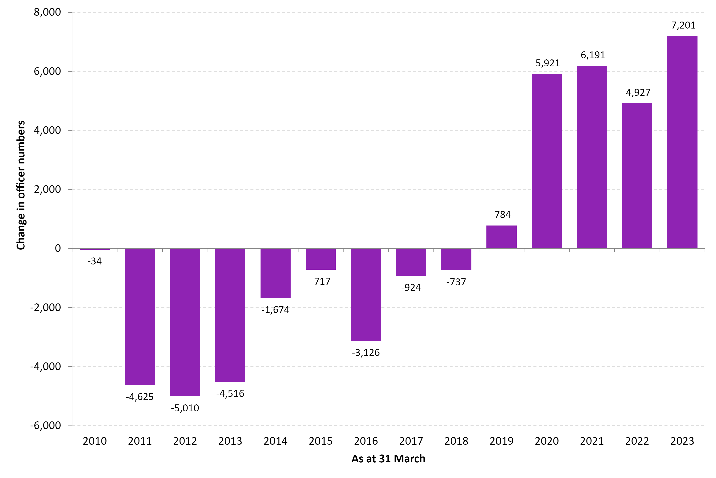

Police Staff Workforce
There are approx. 86k police staff and 9k Police Community Support Officers. In relation to police staff the majority, around two thirds, work in front facing roles which directly support police officers or the public. The main groups of police staff are as follows, along with indicative numbers:
Service Area | 000
Call handlers/ dealing with the public | 18
Intelligence / investigations | 14
Criminal justice | 14
PCSO’s | 9
Custody | 4
Local Policing e.g. community liaison | 2
Enabling services/PCC | 33

Key Service Challenges
These include:
- General service demands, which is driven by population growth, new laws, technology, etc
- Future cost pressures arising from inflation, and general pay costs. In the next 4 years the service will need to find approx. £0.25bn to pay for the expected incremental growth from the 20,000-officer uplift programme.
- Debt levels are increasing due to the need for regular investment in technology, fleet, and estates. Failure to invest leads to reduced service efficiency and rising costs.
- A lack of funding to progress the sustainability agenda.
- Falling reserves, which are being used to support ongoing service delivery.
- The need to improve efficiency and productivity where possible through process review and use of technology, and shared learning (e.g. from the Police Productivity Review). There exists a degree of scope to improve efficiency, but this will take time to maximise. Potential areas include:
  - Third party spend e.g. reductions in the cost of ICT, fleet, estates, commissioned services etc.
  - Improved allocative efficiency of the workforce.
  - Income generation in relation to service delivery
- Overall, the combined effect of inflation, rising debt levels and falling reserves is placing a significant strain on police finances.

Investment needs
These include:
- The need for pay reform to ensure the service attracts the best.
- Investment in control rooms to ensure the service provides a consistent and good level of service.
- The need to increase and upskill the number of detectives across the service.
- capital investment to ensure ongoing and improved efficiency and effectiveness.
- Capital investment to progress the sustainability agenda.

NPCC Finance Committee
March 2024

